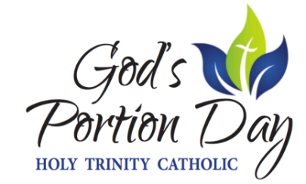

God’s Portion Day 2021 is going to be fun, fast, and fulfilling!
It’s a one day sale…you won’t want to miss out on the fun!

Contact a committee member by OCTOBER 18TH to donate any items to the auction
Solicitation has begun and we are excited to bring you a variety of new and quality items to choose from

Auction Item Viewing: Friday, October 22, 2021
4PM -8PM @ HTC High School
View the auction items Friday night for the opportunity to submit a pre-sale bid on items of interest to you

LIVE AUCTION DAY: Saturday, October 23, 2021
4:00pm – 5:00pm Happy Hour to Kick-off GPD
4:00pm – 7:00pm Sonny’s Supermarket Grilling on the Sidewalk Menu Offered
4:00pm – ??? 2021 Grow-An-Acre Grain Sale with Live Auction to follow
9:00pm $10,000 CASH Raffle Drawing

ALUMNI CHALLENGE & $10,000 CASH Raffle form is enclosed with this flyer
To participate, fill out the form and return/mail it to the HTC West Point Office

$10,000 CASH Raffle and SOMETHING FOR EVERYONE Raffle are BACK this year.
Contact a committee member to purchase tickets
OR
Email HTCGPD2600@GMAIL.COM

THANK YOU to our generous $10,000 CASH Raffle sponsors!
TJ Excavating, Holtkamp’s Floors, Décor & Furniture,
Bella+Row, Blue Top Excavating

WIN AN ELECTRIC BIKE at our HAT RAFFLE!
Purchase one of 12 hats for a chance to win the electric bike

We are looking forward to seeing you on Saturday, October 23, 2021!

Chad & Mindy Ward
Jay & Lisa Griswold
Brad & Maria Walker

